Write a Prolog Program for A DB WITH NAME, DOB.

Aim:
To write a Prolog program to create a database containing Name and Date of Birth (DOB) and to retrieve the details using queries.
Program:
% define some facts about people and their DOBs
dob(john, date(1990, 5, 1)).
dob(jane, date(1985, 12, 10)).
dob(bob, date(1978, 2, 28)).
dob(sue, date(1995, 8, 15)).
dob(tom, date(2000, 4, 22)).
% define a predicate to look up a person's DOB by name
lookup(Name, DOB) :-
dob(Name, DOB).
example query: lookup john's DOB
?- lookup(john, DOB).
DOB = date(1990, 5, 1).

% example query: lookup sue's DOB
?- lookup(sue, DOB).
DOB = date(1995, 8, 15).

OUTPUT

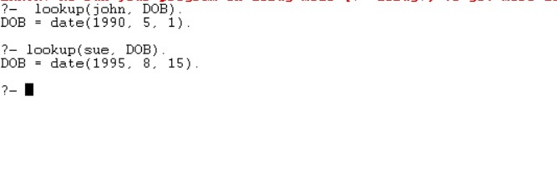FLOW CHART
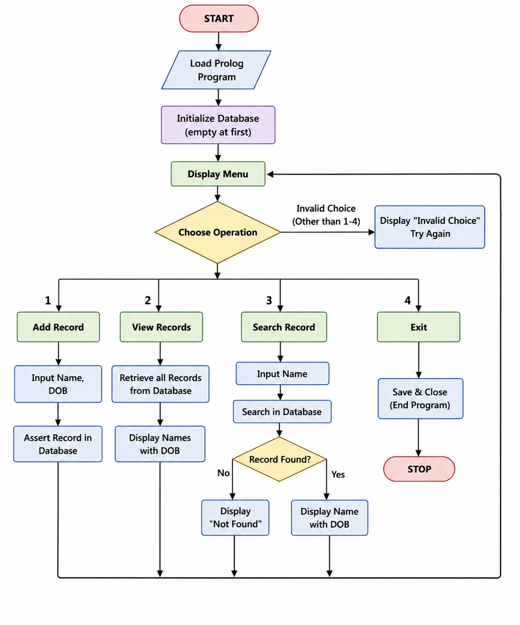
RESULT
The Prolog program was successfully implemented to create and manage a database containing Name and Date of Birth (DOB). The program allows records to be stored, displayed, and searched using Prolog facts and queries.

CONCLUSION
Thus, the Prolog database program was successfully implemented. It demonstrates how facts, rules, and queries can be used to represent and retrieve information in a logical database. The program provides a simple way to store and access Name and DOB records using Prolog.

